Paper-based observation form

This form can be used to submit a paper-based observation. The information will then be entered into
BowTieXP and processed by Flight Safety Air Force.

Dieses Formular kann verwendet werden, um eine Beobachtung in Papierform einzureichen. Die Angaben werden anschliessend in BowTieXP eingegeben und durch Flight Safety Luftwaffe bearbeitet.

Ce formulaire peut être utilisé pour soumettre une observation sur papier. Les informations seront ensuite saisies dans BowTieXP et traitées par Flight Safety des Forces aériennes.

Print out and put in a window envelope
Ausdrucken und in ein Fenstercouvert stecken
Imprimer et insérer dans une enveloppe à fenêtre

Oberst Jan Frasa
Chef Flugsicherheit LW
Aérodrome Militaire
1530 Payerne

General Information for all observations

Name *

Do you agree sharing your contact details other than with Chief Flight Safety? * | ☐ Yes  ☐ No
Date of occurrence *

Local time of occurrence *

Organizational Unit *

Location *

Title *

Description *

Appendix additional information: Page
☐ for aircrew observation 3 – 5
☐ for airprox 6 – 8
☐ for birdstrike 9 – 10
☐ for maintenance / ground staff observation 11 – 12
☐ for para observation 13 – 15

Additional information for aircrew observation

Special type of service * | ☐ Pil S  ☐ OEE  ☐ Display & Display Training
Technical Malfunction * | ☐ Yes  ☐ No  If yes, current Location of Aircraft *  Affected system *  ☐ Hydraulic  ☐ Electric  ☐ Fuel  ☐ Oxygen / pressurization / cockpit environmental control  ☐ Engine  ☐ Flight controls  ☐ Weapons / sensors / ECM  ☐ Propeller / rotor  ☐ Airframe / structure  ☐ Gear / brakes / hook / skid  ☐ Navigation  ☐ Communication  ☐ Crew equipment  ☐ Unknown  Impact on mission *  ☐ None / minor  ☐ Mission abort
Damage (own / third party) * | ☐ Yes  ☐ No  If yes - specify:
Injuries (own / third party) * | ☐ Yes  ☐ No  If yes - specify:
Mission *

Type of aircraft *

Aircraft registration *

Persons on Board
(Crew + Pax) *
Phase of flight * | ☐ Parked  ☐ Taxi / hover taxi  ☐ Take-off / departure  ☐ Enroute / mission  ☐ Approach / landing
Flight Parameters | Speed  Altitude  Performance (Power, Performance Class, AOA, Weight)  Configuration (External Stores, Flaps, Gear, ...)
Airspace Class *
Flight Rules / Level of Control | ☐ VFR  ☐ IFR  ☐ Tactical  If Tactical – specify:
Daylight * | ☐ Day  ☐ Night  Night Vision Device  ☐ Yes  ☐ No
Environmental conditions *

ATC involved * | ☐ Yes  If yes – ATC Unit *  Your call sign
Was situational awareness a contributing factor?

Was communication between team and organizations members a contributing factor?

Was task sharing / responsibilities (team work) a contributing factor?

Was the task challenging / tiring / stressful?
Was the task experience a contributing factor?

Was supervision a contributing factor?

Were procedures or rules a contributing factor?

Was time pressure a contributing factor?

Perceived level of risk (your personal subjective judgement) * | ☐ Low  ☐ Medium  ☐ High
What could be adapted to prevent such incidents in the future?

Additional information for airprox

Special type of service * | ☐ Pil S  ☐ OEE  ☐ Display & Display Training
Damage (own / third party) * | ☐ Yes  ☐ No  If yes - specify:
Injuries (own / third party) * | ☐ Yes  ☐ No  If yes - specify:
Mission *

Type of aircraft *

Aircraft registration *

Persons on Board
(Crew + Pax) *
Phase of flight * | ☐ Take-off / departure  ☐ Enroute / mission  ☐ Approach / landing
Flight Parameters | Speed  Altitude
Airspace Class *
Flight Rules / Level of Control | ☐ VFR  ☐ IFR  ☐ Tactical  If Tactical – specify:
Daylight * | ☐ Day  ☐ Night  Night Vision Device  ☐ Yes  ☐ No
Flight rules / level of control | ☐ VFR  ☐ IFR  ☐ tactical

Environmental conditions *

Conflicting aircraft * | ☐ Own military  ☐ Foreign military – specify below *  ☐ Civil – specify below *  ☐ Drone – specify below *  ☐ Unknown – describe conflicting aircraft below *  Specification/description of conflicting aircraft *
Horizontal position of conflicting traffic at  detection * | 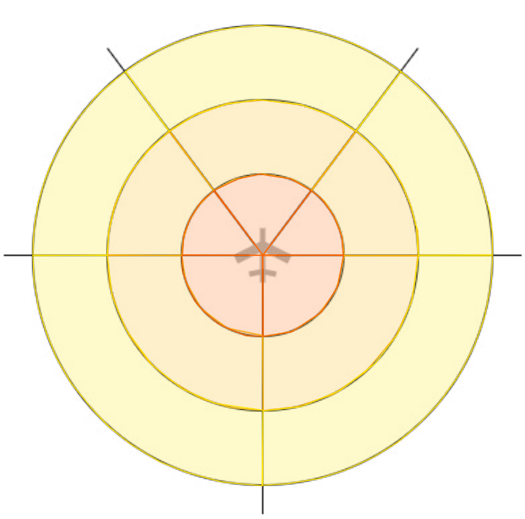
Vertical position of conflicting traffic at  Detection * | 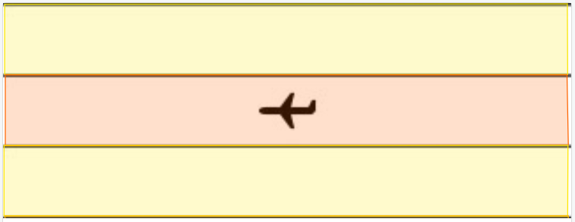
Information / awareness about the conflict * | ☐ None  ☐ Visual acquisition  ☐ Information from ATC  ☐ Onboard sensor  ☐ ACAS traffic advisory  ☐ ACAS resolution advisory (TCAS II only)

ATC involved * | ☐ Yes  If yes – ATC Unit *  Your call sign
Perceived level of risk (your personal subjective judgement) | ☐ Low  ☐ Medium  ☐ High
What could be adapted to prevent such incidents in the future?

Additional information for birdstrike

Special type of service * | ☐ Pil S  ☐ OEE  ☐ Display & Display Training
Damage (own / third party) * | ☐ Yes  ☐ No  If yes - specify:
Injuries (own / third party) * | ☐ Yes  ☐ No  If yes - specify:
Mission *

Type of aircraft *

Aircraft registration *

Persons on Board
(Crew + Pax) *
Point of Impact on Aircraft *
Type of bird * | ☐ Known  ☐ Unknown  State Bird Size  ☐ Small  ☐ Medium  ☐ Large  ☐ Unknown
Approximate number of  birds * | ☐ 1  ☐ 2 - 10  ☐ 11 - 100
Phase of flight * | ☐ Taxi  ☐ Take-off  ☐ Climb  ☐ Enroute / mission  ☐ Descent  ☐ Approach  ☐ Landing
Flight Parameters * | Speed  Altitude  Airfield / Airport (ICAO 4-letter code, i GEL)
Daylight * | ☐ Day  ☐ Night  Night Vision Device  ☐ Yes  ☐ No
Effect on flight | ☐ None  ☐ Aborted take-off  ☐ Precautionary landing  ☐ Engine shutdown  ☐ Other

Additional information for maintenance / ground staff observation

Type of service * | ☐ Professional (BM, Civil employee)  ☐ Military (RS, VbA, DD, WK)
Damage (own / third party) * | ☐ Yes  ☐ No  If yes - specify:
Injuries (own / third party) * | ☐ Yes  ☐ No  If yes - specify:
Maintenance task * | ☐ Preparation / A/C handling  ☐ Maintenance / Repair  ☐ other  If other – specify:
System involved * | ☐ Aircraft Type of aircraft *:  Aircraft registration *:  Current location of aircraft *:  ATA-Codes of affected system *:  ☐ System / other * ☐ Organisation – specify below *  ☐ FIS LW / SAP – specify below *  ☐ Weapon / ammunition – specify below *  ☐ Battery – specify below *  ☐ Firefighting / rescue ☐ Training  ☐ Real event  ☐ Crew equipment – specify below *  ☐ Infrastructure – specify below *  ☐ Airport servicing / maintenance – specify below *  ☐ Specialized vehicles – specify below *  ☐ Other – specify below *  Specify system / other *
Contributing Human Factors * | ☐ None  ☐ Lack of Communication  ☐ Complacency  ☐ Lack of Knowledge or Training  ☐ Distractions  ☐ Lack of Teamwork / Coordination  ☐ Fatigue  ☐ Lack of Resources / inadequate planning  ☐ Pressure  ☐ Lack of Assertiveness  ☐ Stress  ☐ Ineffective Supervision  ☐ Lack of Awareness  ☐ Norms (conflicting Rules or Policies)  ☐ Not taking Ownership
What could be adapted to prevent such incidents in the future?

Additional information for para observation

Type of service * | ☐ Miliz KSK  ☐ Miliz TK/WK  ☐ Miliz MIT  ☐ FD Fsch  ☐ FD Fsch TK  ☐ FD Fsch GK  ☐ FD Fsch MIT  ☐ SPW  ☐ SPW Training  ☐ SPW Demo  ☐ CISM  ☐ CISM Training  ☐ CISM Wettkampf  ☐ CISM Demo  ☐ Zivil mit militärischer Ausrüstung
Damage (own / third party) * | ☐ Yes  ☐ No  If yes - specify:
Injuries (own / third party) * | ☐ Yes  ☐ No  If yes – specify injured body parts and injury:
Type of aircraft * | ☐ PC-6  ☐ Super Puma  ☐ Skyvan  ☐ Other  If other – specify:
Type of exit * | ☐ Dive  ☐ Demi flèche  ☐ Other  If other – specify:
Type of operation * | ☐ HAHO  ☐ HALO  ☐ HAMO  ☐ TIEF (Static line)  ☐ Tandem  ☐ GPADS
Parachute type * | ☐ SF-10 (MC-6)  ☐ RA-360CH  ☐ SIGMA 395  ☐ Gemini 435  ☐ Navigator 280  ☐ GPADS Intruder 360C  ☐ GPADS Intruder Heavy 530  ☐ Gemini 530  ☐ CISM Sport  ☐ CISM Ziel  ☐ AVIATOR  ☐ Other  If other – specify type:  Parachute number *:
Equipment * | ☐ NVG  ☐ Cargo System (SG-7/100)  ☐ Rucksackfixation  ☐ Weapon  ☐ Pistol holster  ☐ PHAOS / SOLR  ☐ Chest Rig  ☐ weapon belt  ☐ Body armour  ☐ Aufkl Weste  ☐ X-Shut Nav console  ☐ EHK / Smartphone / Tablet  ☐ Juggernaut mount light  ☐ Juggernaut mount heavy (heated)  ☐ life jacket  ☐ position light (HEL-STAR, V-Lite)  ☐ Camera  ☐ Helmet  ☐ Bag / Rucksack  ☐ Radio / Headset  ☐ Clothes  ☐ Altimeter  Specify camera type *:  Specify camera mount *:  Specify helmet type *:  Specify bag / Rucksack type *:  Specify clothes *:  Specify altimeter type *:
Phase of flight * | ☐ Climb in A/C  ☐ Exit / Release  ☐ Freefall  ☐ Opening  ☐ Gliding (>500m/AGL)  ☐ Approach (<500m/AGL)  ☐ Landing (<100m/AGL)
Daylight * | ☐ Day  ☐ Night
Environmental conditions | ☐ Presence of clouds at exit altitude or below  ☐ Fog with ground contact  ☐ Any thermal effects  ☐ Relevant surface wind speed at LZ  ☐ Relevant wind speed between ridge and 500m/AGL  ☐ Relevant wind speed above terrain  ☐ Turbulences on final  ☐ Rain  ☐ Snow  ☐ Hail  ☐ No visual ground contact during incident  Specify wind speed *:
Perceived level of risk (your personal subjective judgement) * | ☐ Low  ☐ Medium  ☐ High
What could be improved to prevent such incidents in the future?

